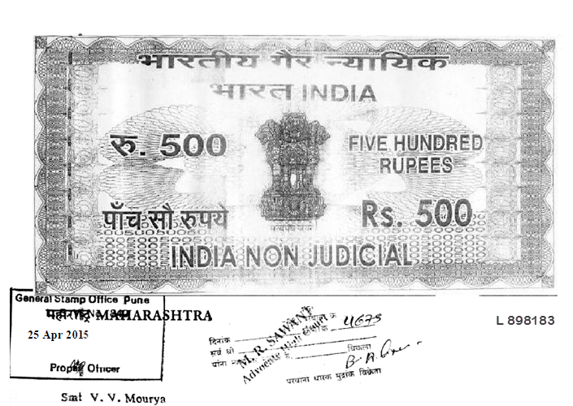

LEAVE AND LICENSE AGREEMENT
THIS LICENSE AGREEMENT is executed at PUNE on this 25th day of April 2015

BETWEEN
Name: - Dr. Shankar Sakharam Kunjir AGE:- 49 Years
Occupation: Service
Address: - Shreyas Residency, Flat No.2, VishaShanti Colony, PimpleSaudagar,
Pune 411027.

(Hereinafter referred as the “LICENSOR” of the FIRST PART)

AND
- Name: -Pravin Babarao Dahare AGE:-30 Years
Occupation: Service
Address:- 31,Ishwar Nagar,Nagpur 440009.

WHEREAS


- The Licensor is the Absolute Owner of: Shreyas Residency,Flat No. 8,VishawaShanti Colony,PimpleSaudagar,Dist. Pune, 411027. Consisting of 1BHK with balcony Which the Licensor has agreed to give on Leave and License basis to the Licensee and the Licensee has been occupying the said premises from 1st DAY OF April, 2015. The Licensee being well acquainted with Licensor, the Licensee requires the said premises for the purpose of residence.

- That the Licensor has permitted the Licensee to use and occupy the said flat/room premises for residential purpose on Leave and License basis for temporary period from 1st DAY OF April, 2015 to 28th DAY OF Feb 2016.

- In consideration of the above, the Licensee agreed to pay to the Licensor and the Licensor agreed to accept from the Licensee, the amount hereunder as mentioned towards the license fee \ compensation for the said premises.

- The Licensee has also agreed to keep an amount of Rs. 30,000/-(Thirty Thousand only) with the Licensor , as and towards the interest free security deposit, returnable on expiration of the period of this License, subject to deductions, if any, as herein after agreed.
- To witness to terms and conditions of the LEAVE AND LICENSE the parties hereto have executed this LEAVE AND LICENSE AGREEMENT.

NOW THIS LEAVE AND LICENSE WITNESSETH

- LICENSE PREMISES:

The Licensor hereby permit and allow the Licensee to use and occupy all that piece and parcel of SAID PRE-MISES, for the purpose of residence of the Licensee, for a period of 11 (Eleven) months only.
- DURATION:

The LEAVE AND LICENSEE AGREEMENT will commence from 1st April 2015 and will remain in force up to 28th Feb 2016, subject to sooner determination as herein after provided.
- LICENSEE FEES:

In consideration of grant of this Licensee by the Licensor to the Licensee to use the said premises, the Licensee agrees to pay to the Licensor as compensation and licensee fee Rs. 10,000/- (Rs Ten Thousand) per month in advance on or before 7th of each month, commence from the date hereof.
- ELECTRICITY CHARGES:

The Licensee shall also bear / pay / and or reimburse to the Licensor if compelled / required to be paid by the Licensor, the MSEDCL electricity consumption bills in respect of the said premises.
- P M C TAXES, WATER AND SOCIETY MAINTAINANCE CHARGES:

During the period of licensor, the licensor shall pay municipal taxes, water and society maintenance charges in respect of premises.
- LICENSEES COVENANTS:

The Licensee, to the intent that such obligation may continue throughout the term of this Licensee, hereby covenants with the licensor as follows:
- To regularly pay the License fee hereby reserved at the time and in the manner aforesaid.
- To use the premises for the purpose of residence so as not to contravene the user thereof as permissible by the authorities concern,
- To observe and comply with all rules, regulations and bye-laws as applicable to occupants of the said society.

- To use the premises with due care and caution and keep the same in good and tenantable condition,
- To carry out all minor repairs such as internal plumbing, electricity if any in the premises
- Not to do or suffer to be done in the premises any act, deed, matter or thing that may cost nuisance or annoyance to the owners of the occupants of the society,

- Not make any structural alteration or addition to the premises
- Not to store any article of combustible or hazardous or inflammable nature in the premises and not impose the premises to the risk of fire or other similar accident,
- At the time of vacating the premises on expiry of the License period the Licensee shall handover the said premises to the Licensor in good condition.

- LICENSOR’S CONVENANTS:

The Licensor intent that such obligations may continue throughout the term of this License, hereby covenant with LICENSEE by paying the License fee hereby reserved and observing and performing the covenants and stipulation here the contained and on its part to be observed and performed, the licensee shall be entitled to peacefully use, occupy and enjoy the premises during the term of the License.

- BARE LICENSEE:

- Nothing here contained shall be construed as creating any lease or tenancy or any other similar right or title of any nature whatsoever in favor of the LICENSEE in to or upon the Premises or as transferring any interest whatsoever there in favor of the LICENSEE, except the permissive use and occupation of the Premises for the period as provided herein and subject to the provision herein contained,
- The Licensor and their agents and all persons authorized by them shall be entitle at all reasonable time in the Licensor’s giving to the LICENSEE 24(Twenty Four) Hours prior notice to enter upon the premises to inspect the state and condition of the premises.

- THEFTS OR LOSS:

The Licensor shall not be responsible or liable for any theft, loss, damage or destructive of any property of the Licensee or any other person lying in the said premises nor of any bodily injury to any person in the licensed premises on account of any cause whatsoever unless directly attributable to actions of the Licensor.

- TERMINATION BY LICENSOR:

- The Licensor shall be at liberty to terminate this License agreement by giving 45 days prior notice in writing to the Licensee. Such termination shall be deemed and is agreed by the party hereto be treated as expiration of the period of license and all consequences thereof shall follow.
- In the event of the Licensee hereby reserved or any part thereof remaining unpaid for 10 days after becoming payable or in the event of the Licensee committing a breach of any of the terms and conditions of this License therein such event the Licensor shall be entitled and be at liberty to determine the License giving 45 days notice in writing calling upon the Licensee to make such payment or to remedy such breath and if the Licensee fails to do so within the period of notice, then in the expiry of the said notice period of 45 days , the License hereby granted shall stand terminated, on such determination the Licensee shall hand over to the Licensor vacant and peaceful charge of the premises and the Licensor shall be entitled to enter upon the premises and exercise its rights. Such termination shall be deemed and is agreed by the parties hereto be treated as expiration of the period of License and all consequences thereof shall follow.

- TERMINATION BY LICENSEE:

The Licensee shall be entitled to terminate this License agreement by giving 45 days prior notice in writing to the Licensor. Such termination shall be deemed and is agreed by the parties hereto be treated as expiration of the period of License and all consequences thereof shall follow.

L) NOTICE:

Any notice required to be given hereunder shall be given by only registered post acknowledgement due to the address of the Licensor. First here in above and the Licensee at the premises and shall be deemed to have been received by the addressee, on the expiry of seven days from the day on which it was so delivered at the post office or on receipt of acknowledgement.

- ACTIVITY OF LICENSEE:

- The Licensee shall use the premises for purpose of residence.
- The Licensee shall use the said premises himself and his family members and shall not allow any other person not shall assign, nor sub-license the same or any part thereof, to any person, or create any third party interest in the said premises.

- SECURITY DEPOSIT :

- The Licensee has also agreed to keep an amount of Rs. 30,000/- (Rupees Forty Thousand only) by cash with the Licensor as and towards the interest free security deposit returnable on expiration of the period of this License, subject to deductions if any as hereafter agreed.
- The Licensor shall return / refund the amount of security deposit kept by the Licensee on or at the time of ceasing the use of the said premises by the Licensee and handover of the possession thereof, by the Licensee to the Licensor. The Licensor however, shall be entitled to deduct from the said security deposit, only the amount of the License Fee, if found to be payable / liable to be reimbursed by the Licensee.
- It is hereby agreed that in the event of this License Agreement being determined / terminated prior to the terms hereof for the reason whatsoever, the Licensor shall forthwith upon such determination or termination refund to the Licensee the security deposit.

- POSSESSION:

- The Licensee shall handover the possession of the said premises on the expiration of the License Period to the Licensor in the same condition in which the Licensor has given it to the Licensee.
- After the termination of this License, by efflux of time or otherwise, the Licensee shall handover the possession of the said premises to the Licensor in the same condition in which the Licensor has given it to the Licensee.
- On failure on the part of the Licensee, to handover the possession thereof, to the Licensor, after the expiration of the period of this License Agreement or the earlier termination or determination, thereof, the Licensor shall be entitled to claim, double the License Fee, as compensation from the Licensee.
P)

a) The parties hereto declare and agree and shall always be deemed to have admitted that this is purely a License and no right of any nature such as tenancy, have been created and / or intend to be created in favor of the Licensee in respect of the said premises. The party also agrees not to contain any thing contrary hereto

b) It is declared by the parties hereto that this LEAVE AND LICENSE AGREEMENT shall be subject to the provisions of Maharashtra Rent Control Act 1999.

c) The parties hereto have executed this License on Non-Judicial Stamp Paper. The Original License shall remain with the Licensor and a copy thereof, with the Licensee.
In WITNESS WHERE OF the parties hereto put their hands the day and year first herein above written.

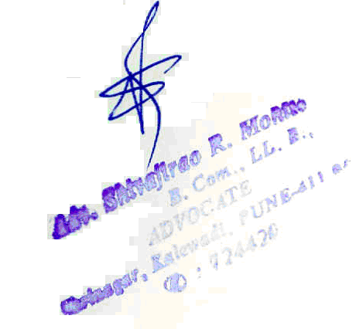

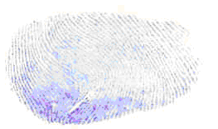
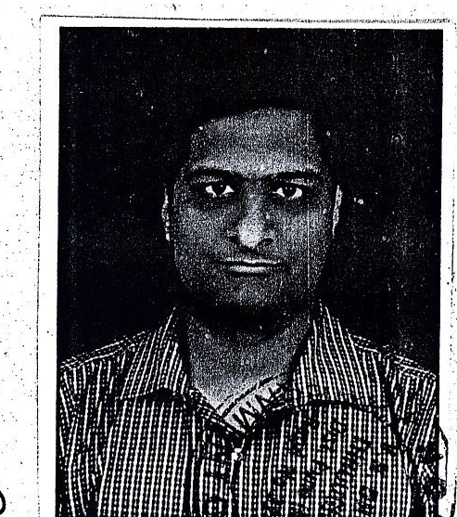

Shankar Sakharam Kunjir
Licensor

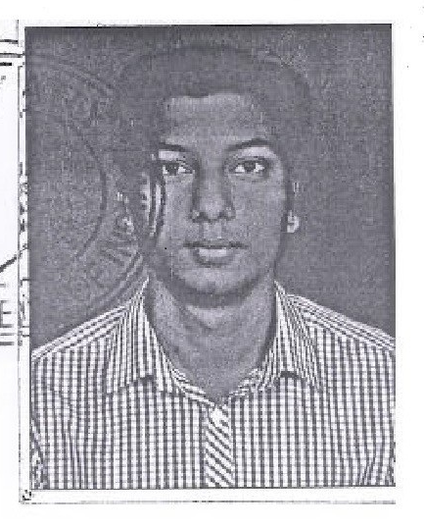

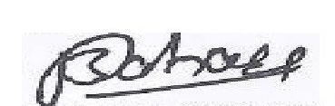
Pravin Babarao Dahare

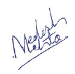

Witnesses:
- Rakesh Badwaik
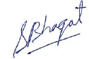
D 101, Kunal-Icon, Jagtap Dairy,Pipmle Saudagar Pune-411027
2. Swapnil Joshi
A 5, Rakshak Society, Pimple Gurav, Pune-411027


